Java 17 Features:

Switch Pattern Matching (Preview)

In earlier releases, the selector expression must evaluate to a number, string or enum constant, and case labels must be constants.

However, in this release, the selector expression can be of any type, and case labels can have patterns.

A switch statement or expression can test whether its selector expression matches a pattern, which offers more flexibility and expressiveness compared to testing whether its selector expression is exactly equal to a constant.

This is a preview feature. It may get removed from future release.

Sealed Classes:
Sealing allows classes and interfaces to define who can extend/implement them.

As an example, imagine a business domain that only works with cars and trucks, not motorcycles. When creating the Vehicle abstract class in Java, we should be able to allow only Car and Truck classes to extend it. In that way, we want to ensure that there will be no misuse of the Vehicle abstract class within our domain.

In Java 15, sealed classes were introduced as preview.
Motivation is “Code reuse is not always the goal”.

To seal an interface, we can apply the sealed modifier to its declaration. The permits clause then specifies the classes that are permitted to implement the sealed interface:

public sealed interface Service permits Car, Truck {
int getMaxServiceIntervalInMonths();
default int getMaxDistanceBetweenServicesInKilometers() {
return 100000;
}
}

Sealed Classes:

Similar to interfaces, we can seal classes by applying the same sealed modifier. The permits clause should be defined after any extends or implements clauses:
public abstract sealed class Vehicle permits Car, Truck {

protected final String registrationNumber;

public Vehicle(String registrationNumber) {
this.registrationNumber = registrationNumber;
}

public String getRegistrationNumber() {
return registrationNumber;
}

}
A permitted subclass must define a modifier. It may be declared final to prevent any further extensions.

A permitted subclass may also be declared sealed. However, if we declare it non-sealed, then it is open for extension.

A sealed class imposes three important constraints on its permitted subclasses:
- All permitted subclasses must belong to the same module as the sealed class.
- Every permitted subclass must explicitly extend the sealed class.
- Every permitted subclass must define a modifier:final,sealed, or non-sealed.

Sealed classes work very well with records. Since records are implicitly final, the sealed hierarchy is even more concise. Let's try to rewrite our class example using records:
public sealed interface Vehicle permits Car, Truck {

String getRegistrationNumber();

}

public record Car(int numberOfSeats, String registrationNumber) implements Vehicle {

@Override
public String getRegistrationNumber() {
return registrationNumber;
}

public int getNumberOfSeats() {
return numberOfSeats;
}

}

public record Truck(int loadCapacity, String registrationNumber) implements Vehicle {

@Override
public String getRegistrationNumber() {
return registrationNumber;
}

public int getLoadCapacity() {
return loadCapacity;
}

}

Enhanced Pseudo-Random Number Generators. This new feature adds a new java.util.Random.SplittableRandom class, which uses a more advanced algorithm called a splitmix64 generator. splitmix64 generator is more secure than the LCG algorithm and renders better performance.

Graal Compiler is removed. Applet API is removed because browsers are no longer supporting them.

Java 11 Features:

New HTTP (and WebSocket) Client:
It aims to replace HttpUrlConnection class.
Until very recently, Java provided only the HttpURLConnection API, which is low-level and isn't known for being feature-rich and user-friendly.
Therefore, some widely used third-party libraries were commonly used, such as Apache HttpClient, Jetty and Spring's RestTemplate.
The HTTP client API implements HTTP/2 and Web Socket.
The API is now fully asynchronous (the previous HTTP/1.1 implementation was blocking).

The following were added:
- HttpClient is the entry point for utilising the API.
- HttpRequest is a request to be sent through the HttpClient.
- HttpResponse is the result of an HttpRequest call.
- WebSocket is the entry point for building up a WebSocket client.

Running java file with single command:

Before jdk 11, there were 2 steps to run java code.
-> javac compilation and the java filename to run.

But now, we can directly use java <filename> command to directly run the java file.

Converting Collection to an array:
The java.util.Collection interface contains a new default toArray method.

List sampleList = Arrays.asList("Java", "Kotlin");
String[] sampleArray = (String[]) sampleList.toArray(String[]::new);
System.out.println(Arrays.toString(sampleArray));

New Utility methods in String:

repeat(int): method repeats the string number of times passed in the parameter.
Lines(): method returns stream of strings, which is a collection of all substrings split by lines.
IsBlank():returns boolean. Empty string and string with only white spaces are treated as blank.
StripLeading(): remove whitespace in the beginning of the string.
StripTrailing(): remove whitespace in the end of the string.
Strip(): remove whitespace from beginning and ending of the string and return the string.

String s = "abc";
System.out.println(s.repeat(10));
String g = "Hi this is line 1. \n Hi This is line 2 \n Hi This is line 3.";
g.lines().forEach(t -> {System.out.println(t);});
String ss = " ";
System.out.println(""+ ss.isBlank());
String d = " aaaaaaaaaa ";
System.out.println(d);
System.out.println(d.stripLeading());
System.out.println(d.stripTrailing());
System.out.println(d.strip());

Output:
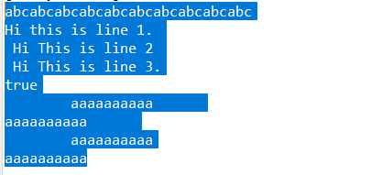

Local Variable Syntax for Lambda Expressions:

var is keyword in java that is used to declare local variables. In java 11, we can use var with lambda expression parameters to avoid using the type name with variable name. In earlier version, this use of var was not allowed.

(var s1, s2) -> s1 + s2; // no skipping allowed.
(var s1, String s2) -> s1+s2; // no mixing allowed.

Var s1 -> s1 // paranthesis is mandatory if we are using var

Nested Based Access Control:
Before Java 11, if we have private members in our code then the compiler creates accessibility-broadening bridge methods that increases the size of application and may lead to confusion. That's why java improved nest based access control.

Java 11 allows classes and interfaces to be nested with each other. These nested types can be private fields, methods, constructors.

If we compile the above source, it will generate four classes,Alphabet, Alphabet$A, Alphabet$B, and Alphabet$B.B1, even a nested class is a typical class with a unique name. The JVM access rule will not allow private access within different classes.
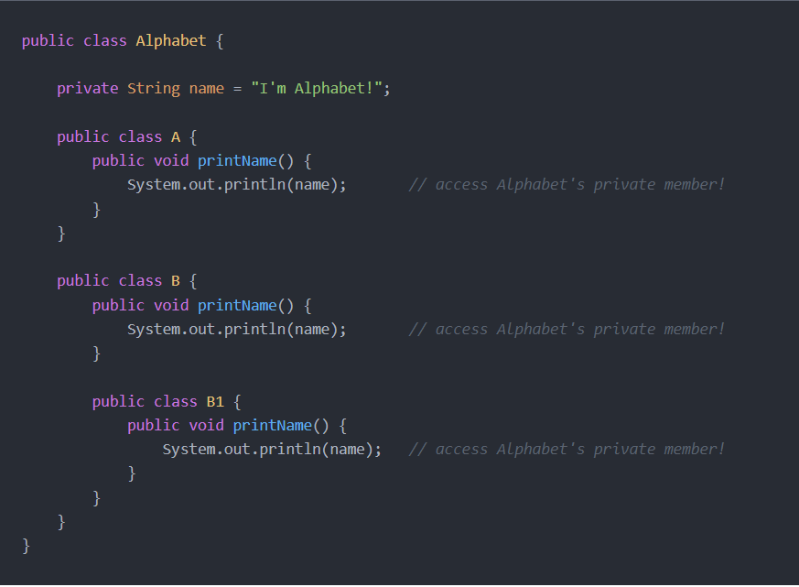

In Java 11, it supports private access within nest members directly, with NO bridge method.

Some new APIs to validate the nested members.
- getNestHost
- getNestMembers
- isNestmateOf

Reading/Writing String to and from files:
readString(): read from file and return string.
WriteString(): write into file.
IsSameFile(): test whether two paths point to same file.

Files.writeString(Path.of("C:\\Users\\sehga\\OneDrive\\Desktop\\qq.txt"), "This should be written into file");
System.out.println(Files.readString(Path.of("C:\\Users\\sehga\\OneDrive\\Desktop\\qq.txt")));

Pattern recognizing methods:
asMatchPredicate(): Method will create a predicate if pattern matches the input string.

Predicate<String> str = Pattern.compile("a").asMatchPredicate();
boolean b2 = str.test("a");
System.out.println(b2);
Output: true

Optional.isEmpty():
The isEmpty method of the Optional class is an object method that is used to check if the object contains a value or not. The method returns true if a value is not present. Otherwise, it returns false.

TimeUnit Conversion: Convert time to day, month year.
// Convert hours to days
TimeUnit t2 = TimeUnit.HOURS;
System.out.println(t2.toDays(72));
// Convert 1 day to hours
TimeUnit t = TimeUnit.DAYS;
System.out.println(t.toHours(1));

